This fact sheet explains how to identify if you are likely to have lead in your water supply and how to minimise the concentration consumed. Lead is commonly found in air, soil, food and water. Accumulation of lead in the human body can be harmful, with pregnant women and children being at a higher risk. Studies have shown that high lead concentrations effect mental development and may be a factor in behavioural problems. It is therefore advisable to keep lead levels in drinking water as low as possible.

How does lead get into drinking water?

Lead can be picked up from service pipes and plumbing within the property. Service pipes connect each property to the water main. The internal plumbing may have lead pipework or lead-based solder in the pipe joints, depending on the property’s age. To reduce the risk of lead entering the water supply, SES Water treats its water with phosphate at treatment works. This forms a protective layer inside the pipes, which acts as a barrier and reduces the amount of lead entering the water.

Does my house have lead pipes?

Lead was commonly used as a material for service pipes up until 1970. If your home was built before that time, it may have lead pipes. You should be able to see your service pipe by locating the internal stop cock, usually located under the kitchen sink or stairs (If you are unsure please seek advice from a qualified plumber). Unpainted lead pipes are a dull grey colour, although a shiny silver colour is revealed if they are scraped or cut.

Other commonly used pipe materials are copper (dull brown), iron (dark grey or brown) and plastic (grey, black or blue). If you are unsure what the pipe is made of, we may be able to tell you by checking our records, please contact developer services for advice.

Even if the water pipe in your home is made of other materials, lead may still be present in the water, if a lead-based solder has been used (see below for more details).

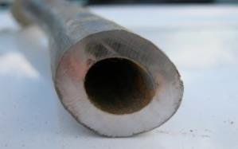
[An Example of a Lead Pipe]

Where can lead-based solder be used?

The Regulations which cover plumbing systems in England do not allow the use of lead-based solder in domestic hot and cold water systems. It can only be used where the water is not consumed, such as the central heating system. There have been many cases of lead poisoning due to the illegal use of lead-based solder. Any lead-based solder that has been used illegally must be replaced with lead-free solder on the pipework joints. Installers may face criminal prosecution if they have contravened the Regulations.

How can I find out the lead level in my water?

Our Customer Services team can arrange for your water supply to be tested. We do not charge for this service, although you may be charged if the property has previously been tested for lead, in which case you will be advised accordingly.(1)

- Please note if you have had any plumbing works carried out on the internal or external pipework at your property, please wait at least 4 weeks before testing to ensure that a representative result can be obtained.
Who is responsible for the pipework?

The service pipe linking our water main to a private property is in two sections. We own the first section (the communication pipe), which runs from our water mains to the street boundary. A stop cock is usually located at this point. The remaining pipework (the supply pipe) is the responsibility of the property owner (Please see diagram below showing the ownership boundary).

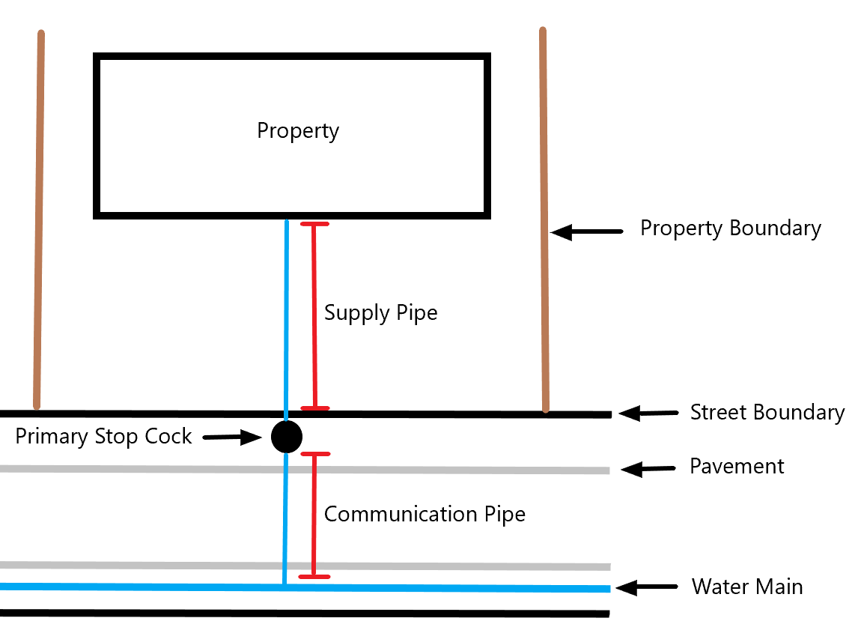

How can I minimise lead levels in my drinking water?

The following actions will reduce the amount of lead consumed:

- For drinking and cooking, only use water from taps fed directly from the water main, e.g. the kitchen cold tap.
- Do not drink water that has been standing in lead pipes for long periods, for example overnight. Flushing a toilet is usually sufficient to draw off the water standing in the service pipe. Otherwise fill a bowl of water at the kitchen sink to draw through fresh water from the mains.
- When having plumbing work carried out, check that lead-free solder is used and if you have lead pipes, flush the cold water kitchen tap for at least 10 minutes before using the water again. Over the next three days you should also flush the tap for 2 minutes after periods of non-use, such as first thing in the morning, to clear any lead particles dislodged by the work.
- Consider replacing the lead pipework.

Free Lead Pipe Replacement Scheme

We routinely replace lead communication pipes, for example when we are laying a new water main or if a high level of lead is detected in a water sample taken at the property.

We also replace lead communication pipes when the customer (or property owner) replaces their part of the service pipe, providing it is also made of lead.

All existing household properties are eligible under this scheme, as well as selected properties such as schools and hospitals (you will be required to have a current account number to participate in the scheme). Properties on shared service pipes are also eligible.

Under the scheme we replace the communication pipe at our expense providing the required route of the new pipe does not involve abnormal costs. If it does, we will subsidise the cost of the work.

We will need to inspect and pass your newly laid supply pipe in accordance with the Water Supply (Water Fittings) Regulations 1999, prior to connection onto our water main. Please refer to our fact sheet on laying a new supply pipe for further details (this is located on our website in the Developer Services section).

If you are using an approved contractor under the Water Industry Approved Plumbers Scheme (WIAPS), we will require a signed completion certificate prior to connecting the new supply to our water main. We would recommend the use of a WaterSafe approved plumber for any remedial works, more information can be obtained at www.watersafe.org.uk

Please contact our Developer Services team for more details.

